## **Type of OLAP cubes ROLAP** Types of OLAP

**MOLAP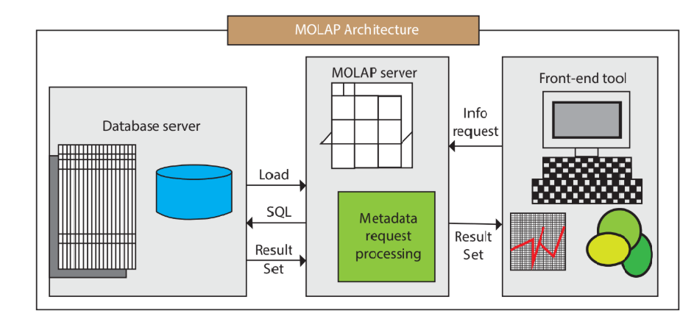HOLAP**

# **OLAP Operations**

## **Roll-up**

## **Drill-Down**

## **Slice**

## **Pivot**

